Downloaded nodejs from nodejs.org

Installed

Then in terminal insalled this 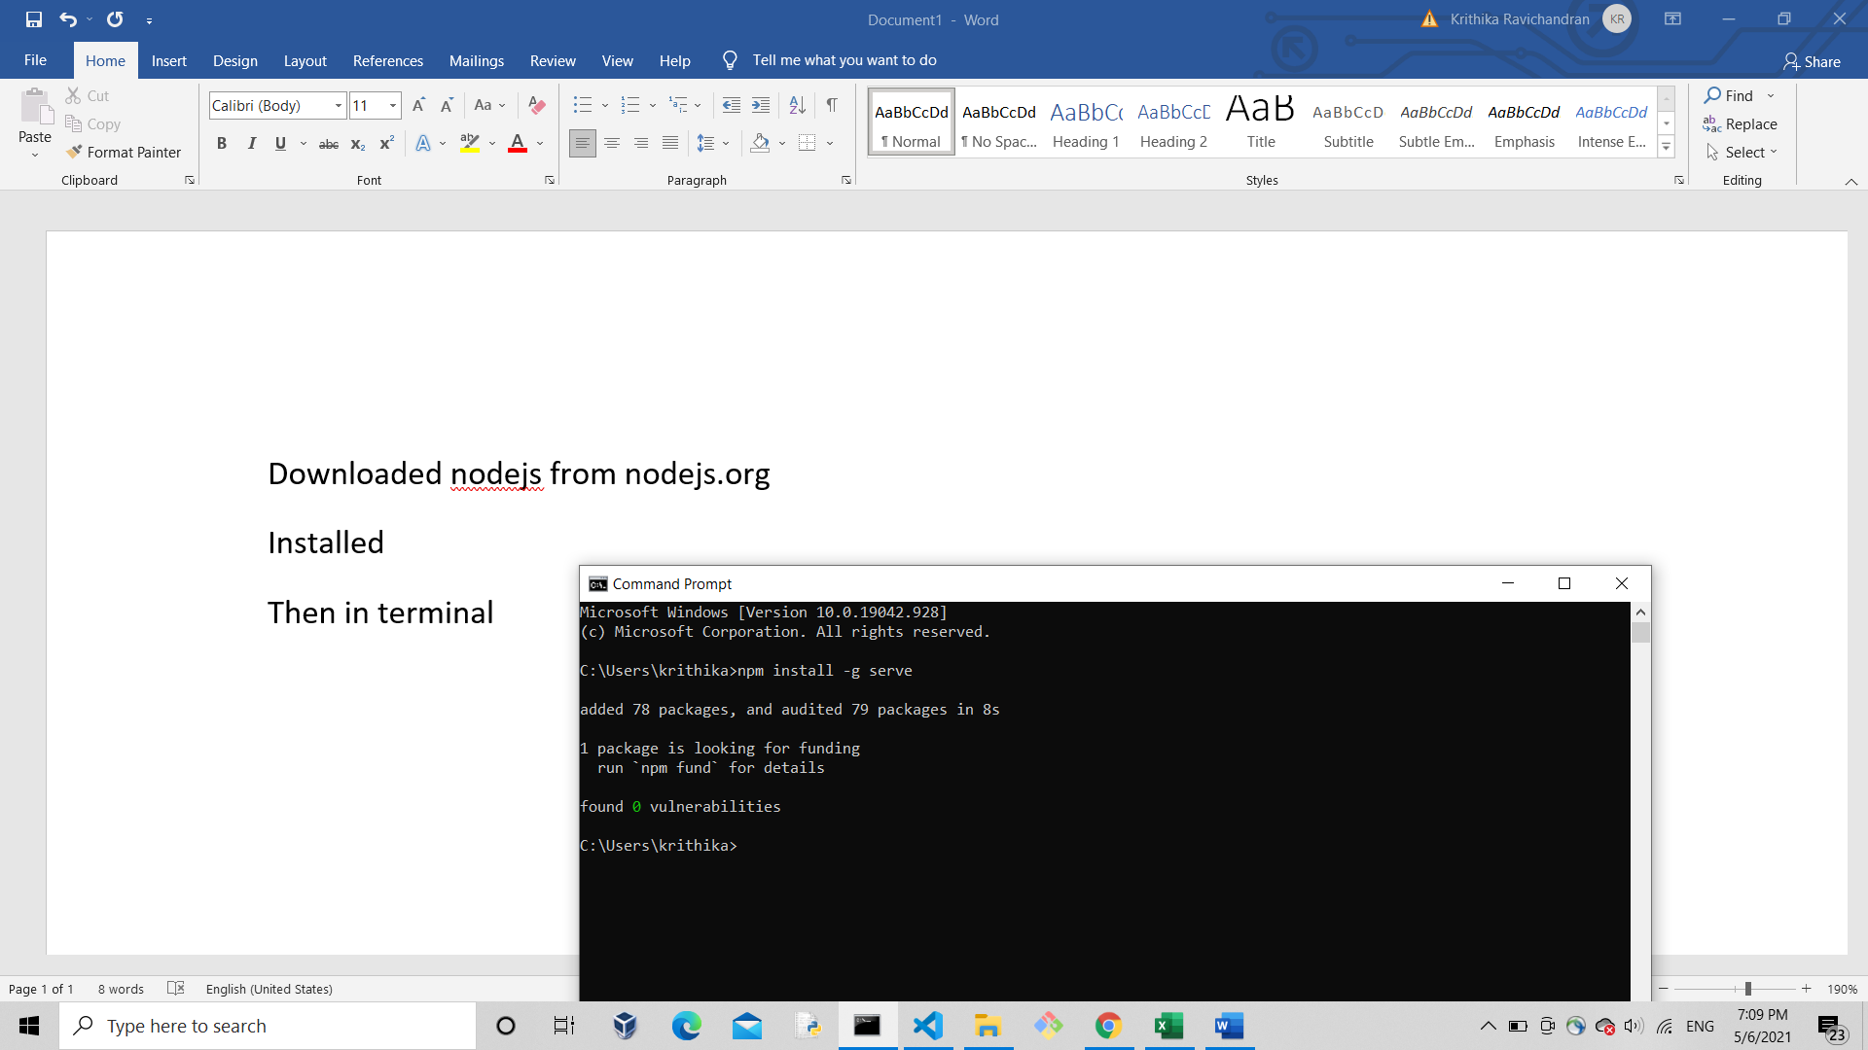

Then vs code navigate to the project and typed serve

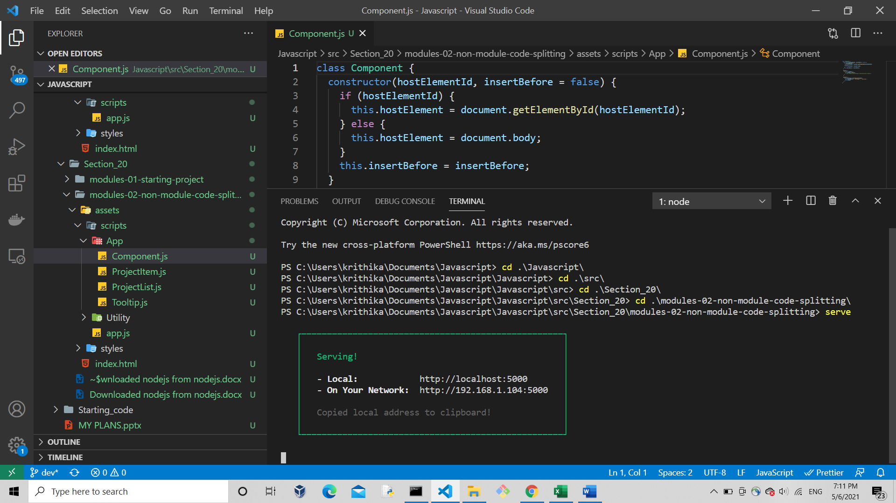

Then click on link to view you website

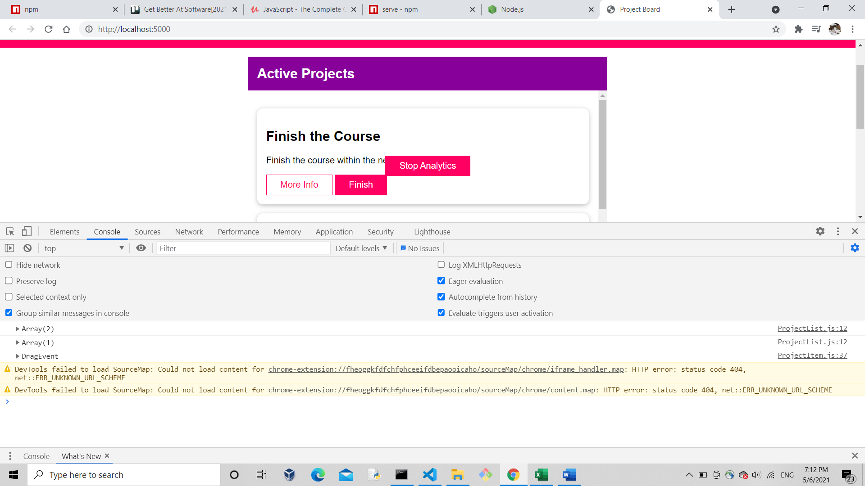

Section 21

Go to view => extensions => install eslint

Typed npm init

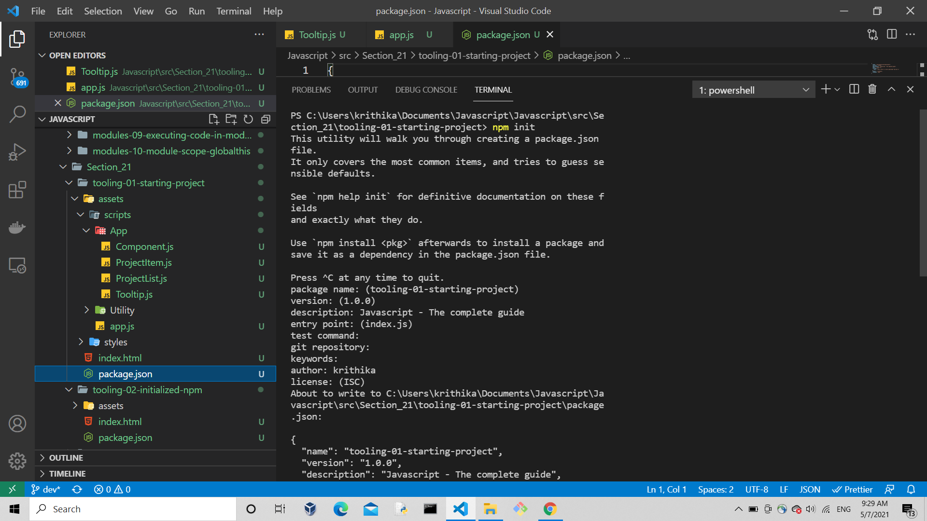

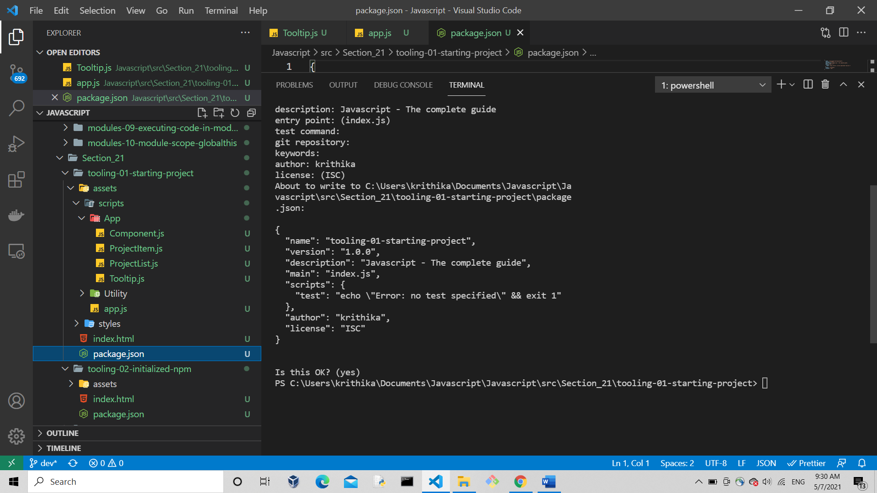

After doing all these package.json was automatically created with the details which I gave

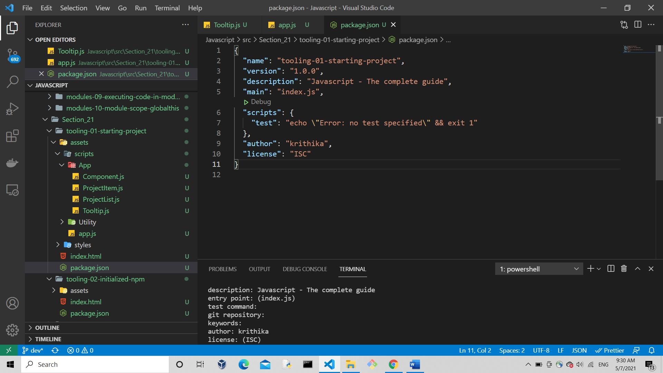

Then installed eslint for this project alone

It creates package-lock.json file

Also u’ll have node modules folder which has dependencies you installed

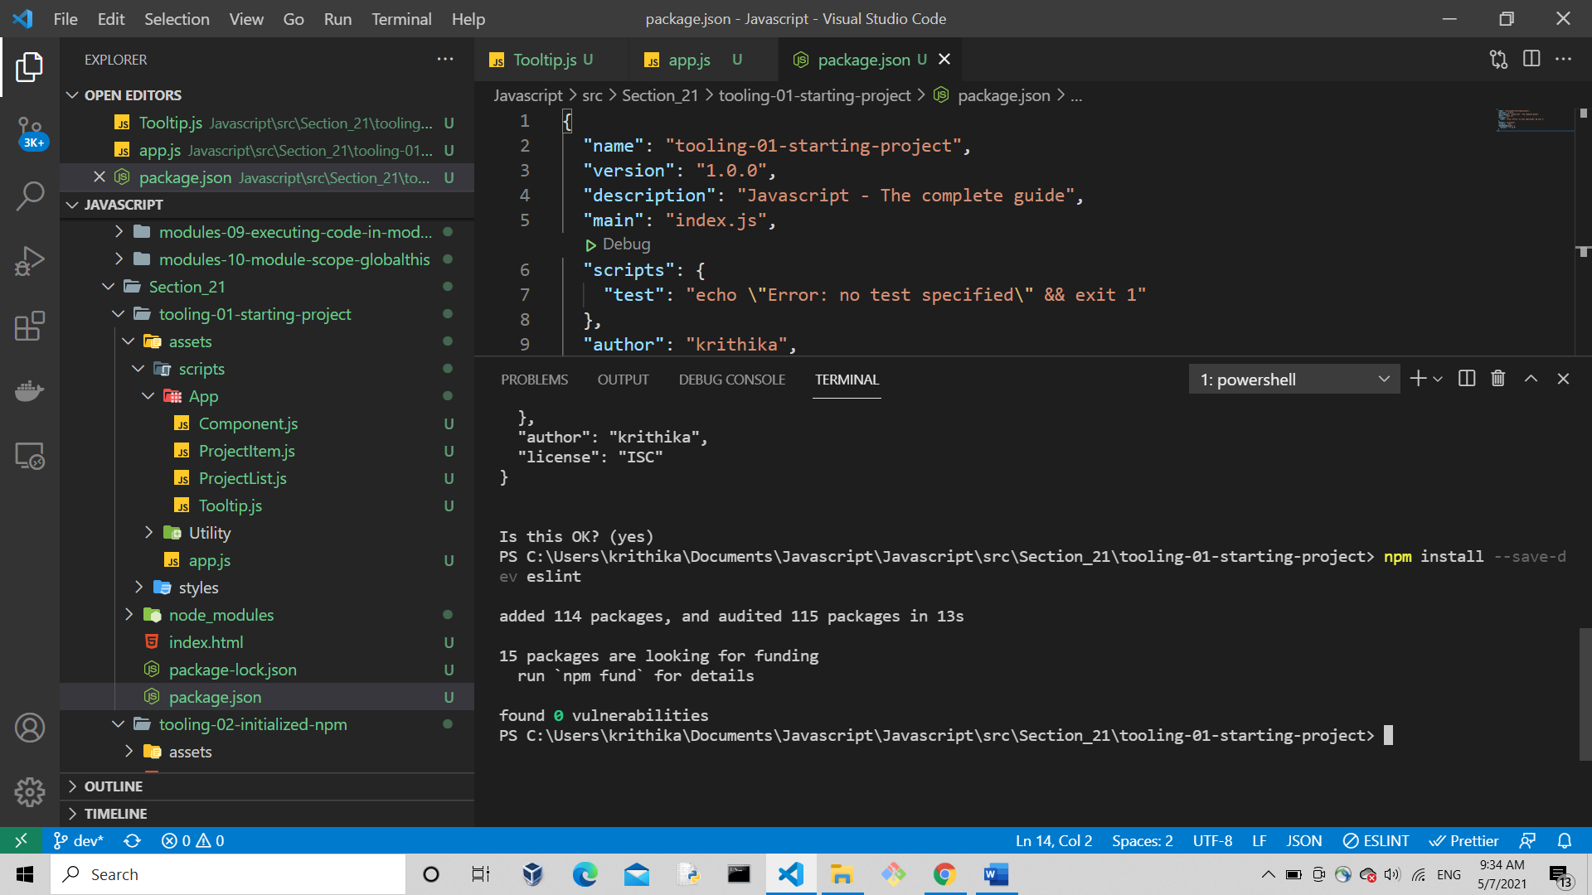

Got error : so use the following

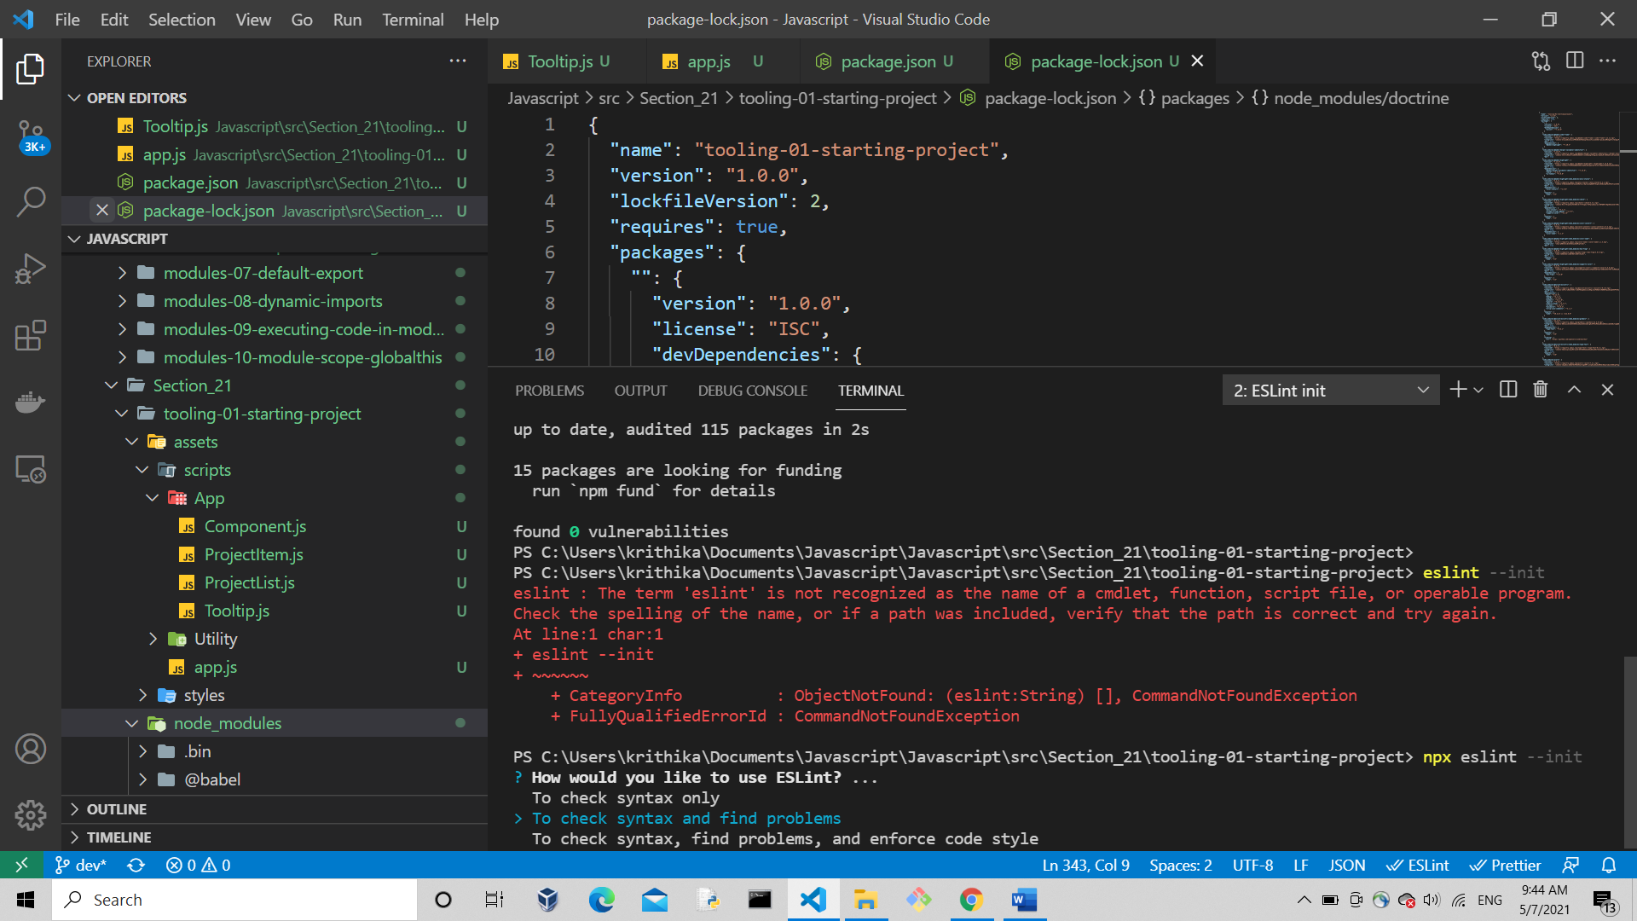

<https://github.com/eslint/eslint/discussions/13686>

<https://stackoverflow.com/questions/37705440/eslint-is-not-recognized-as-an-internal-or-external-command>

selected last option to check syntax, find problems,

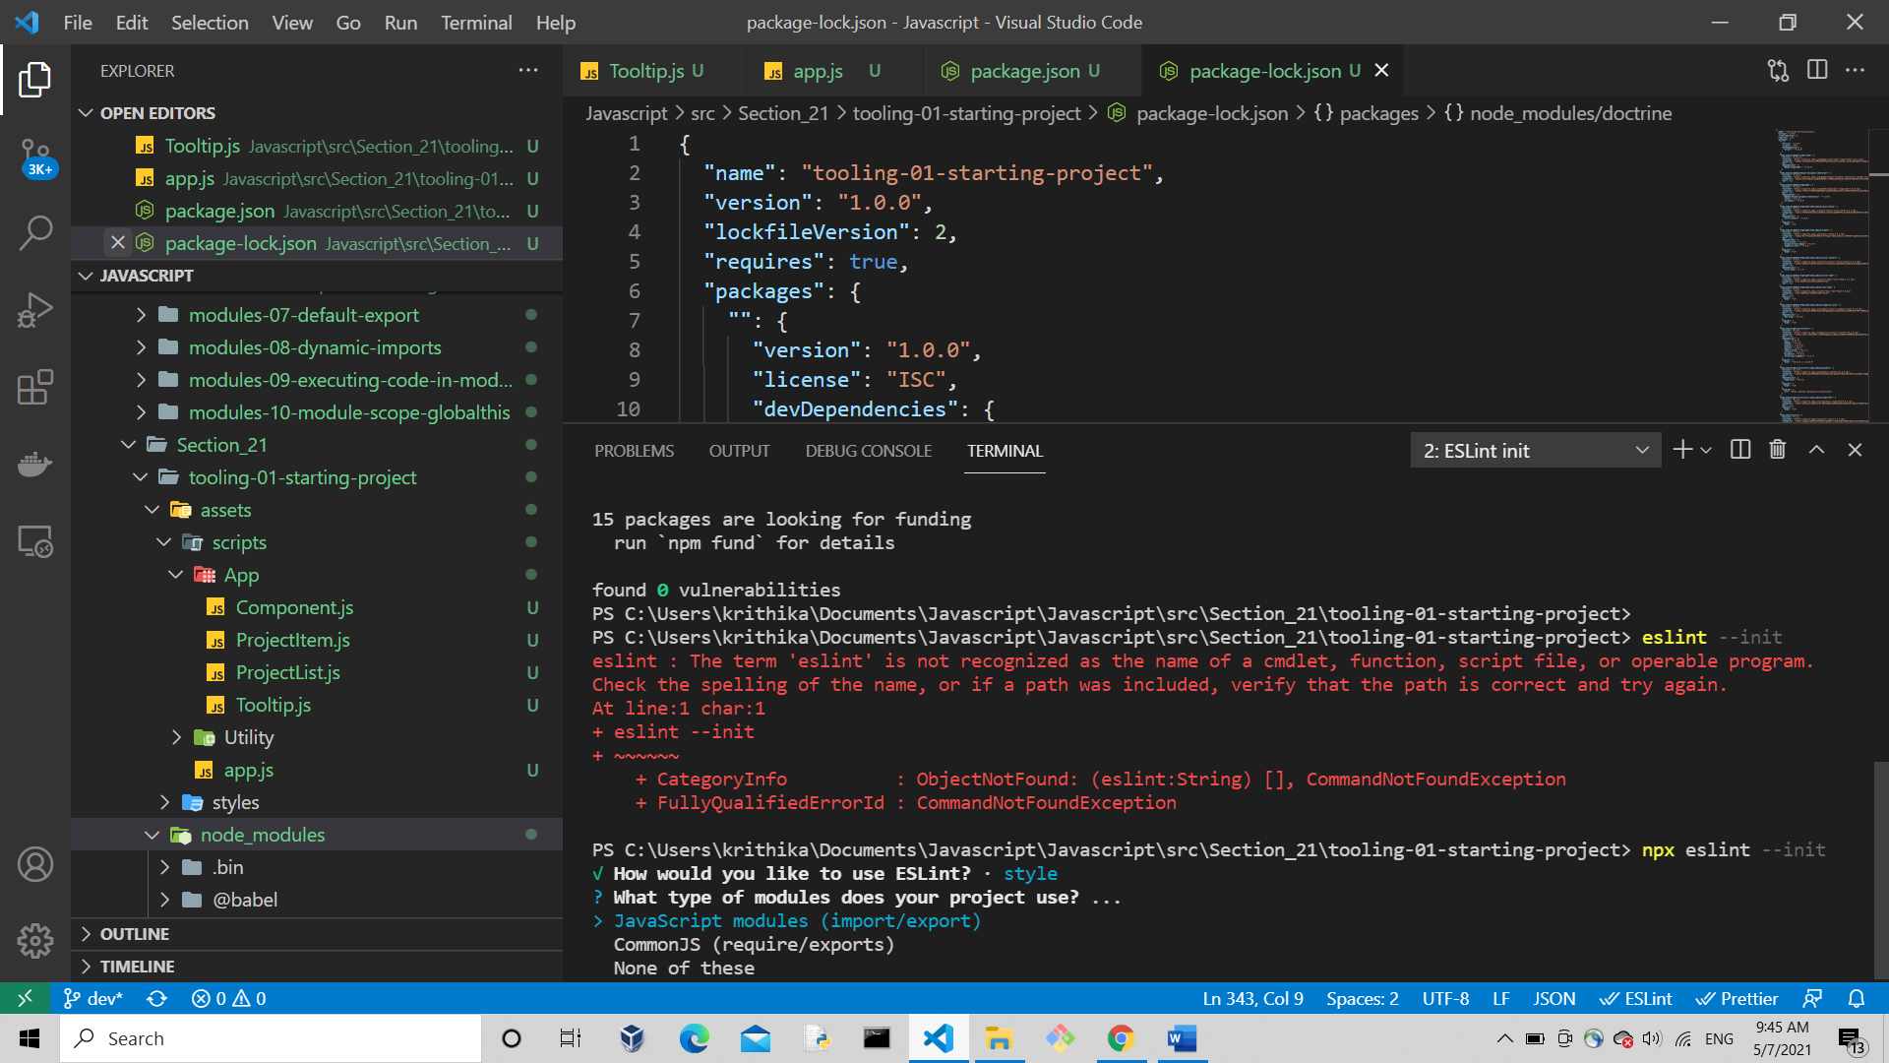

Then chose javascrit modules (import/export)

Then chose none

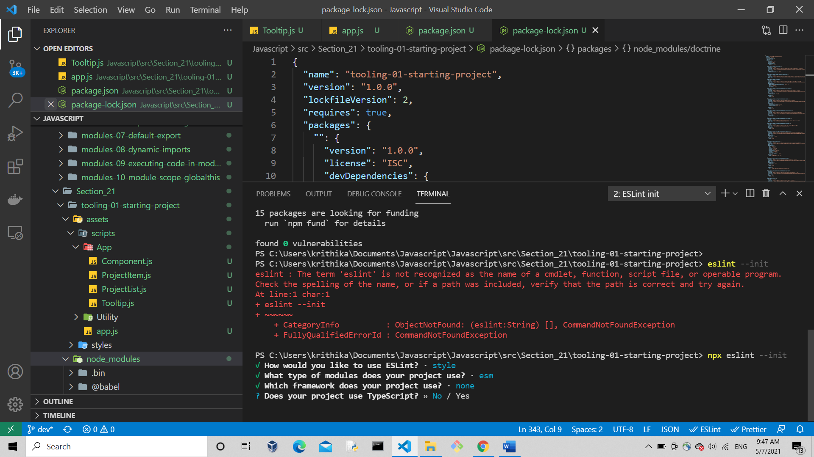

Then no

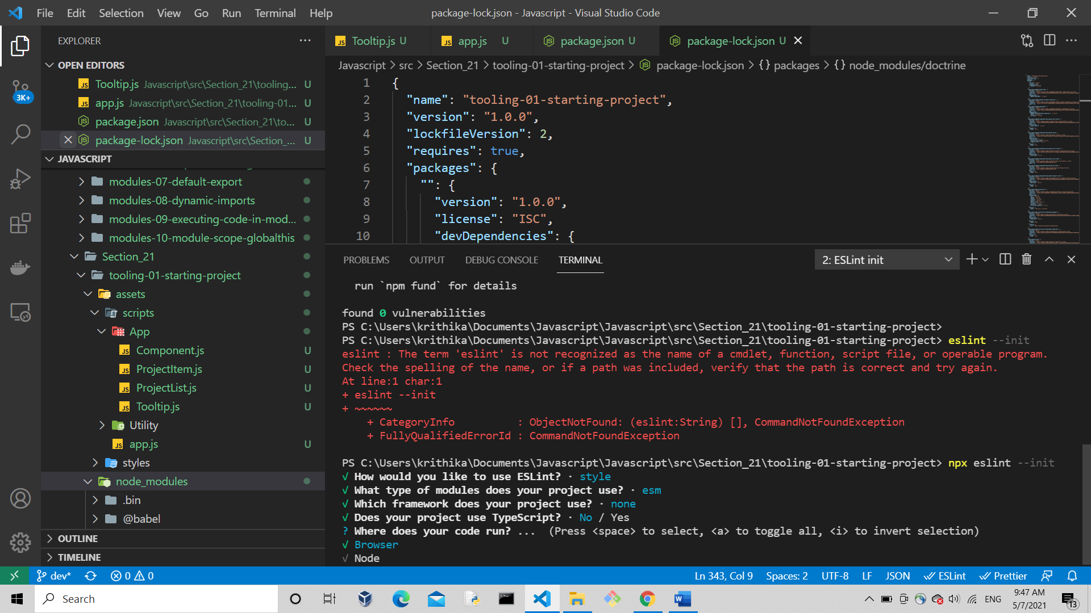

Then browser

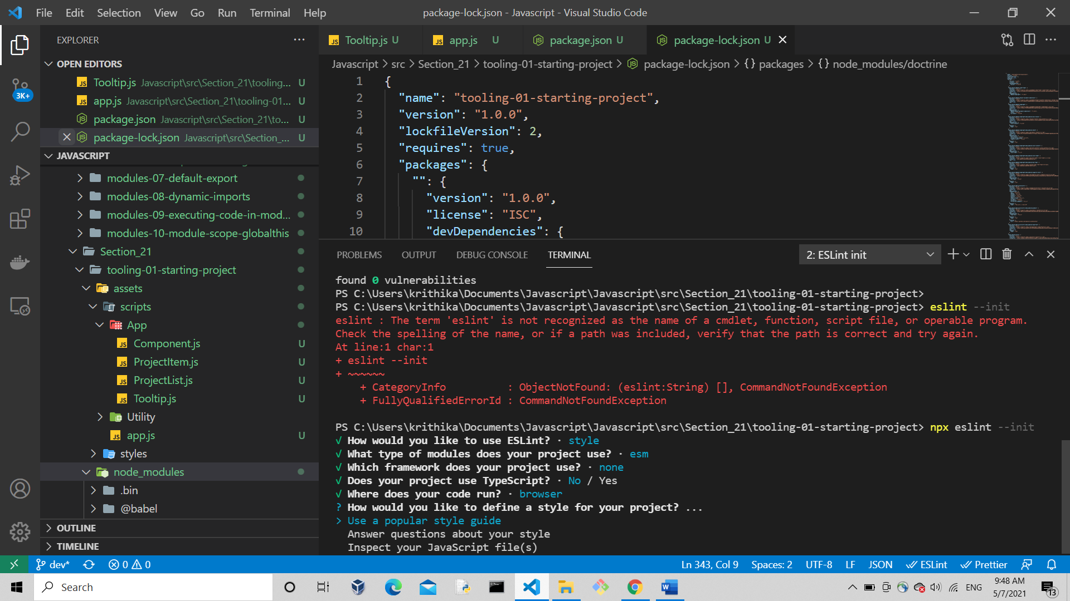

Then last option inspect ur js file

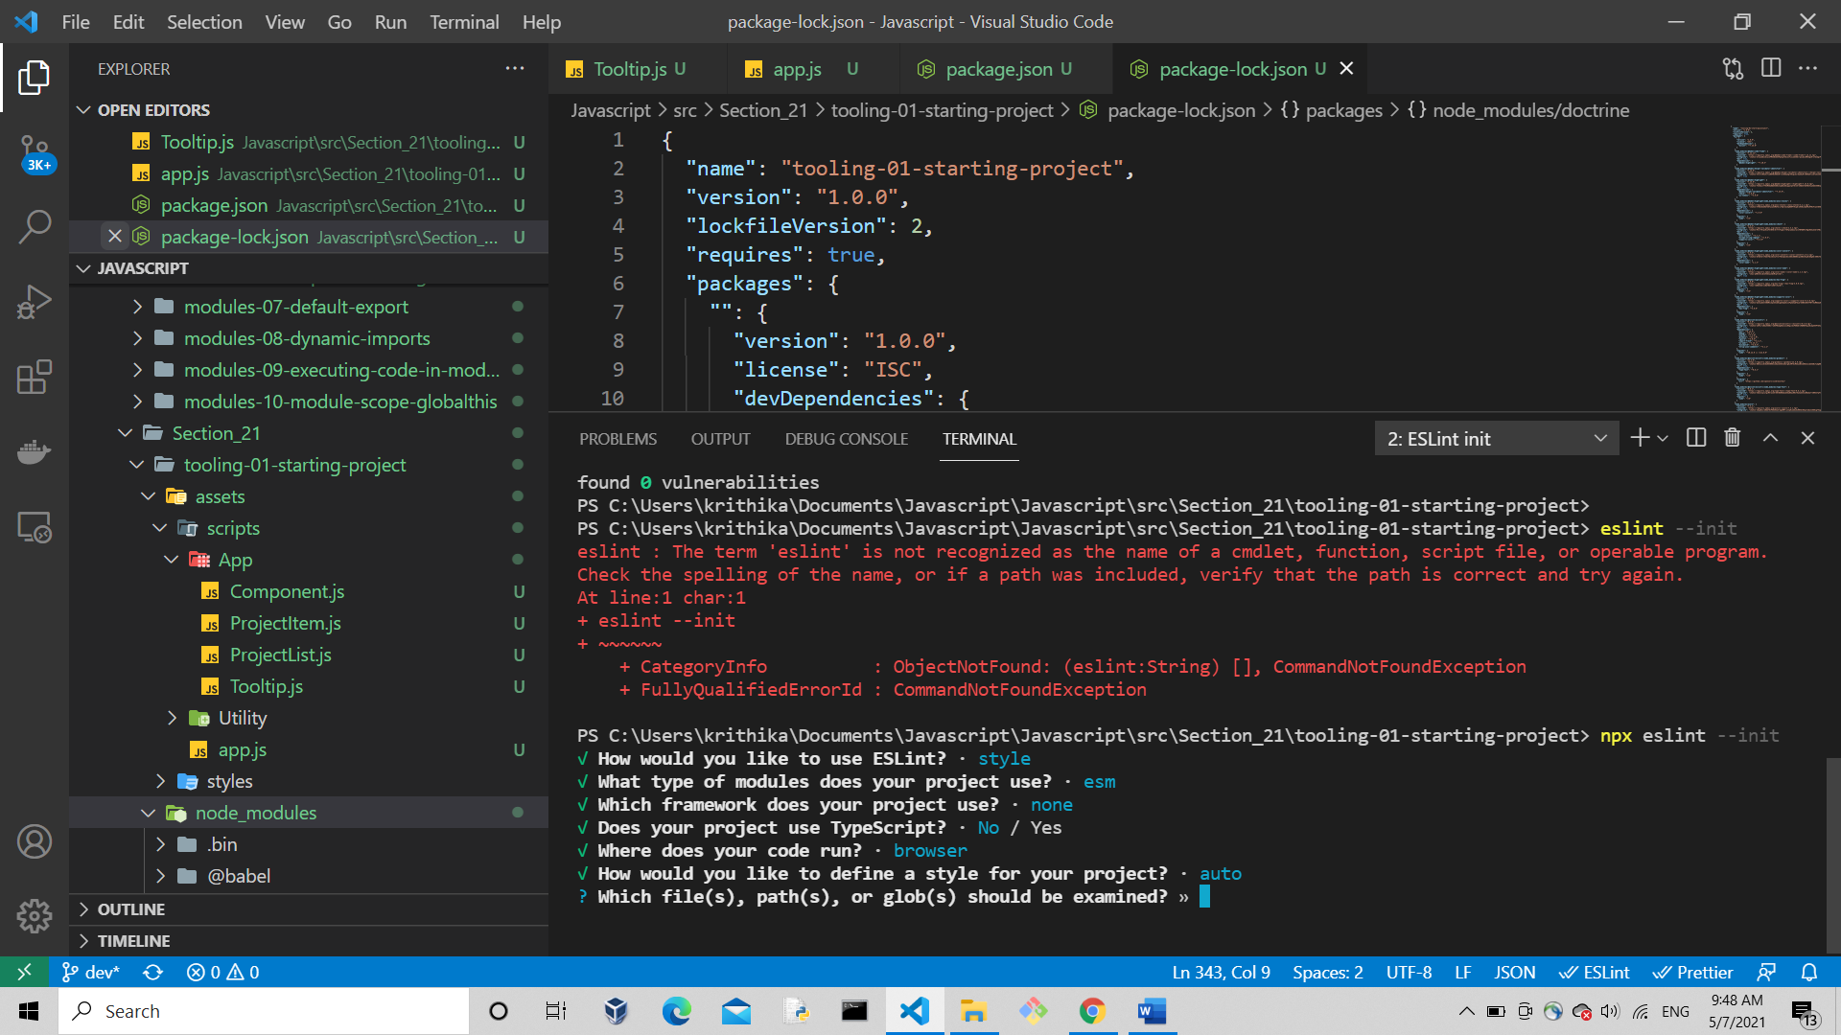

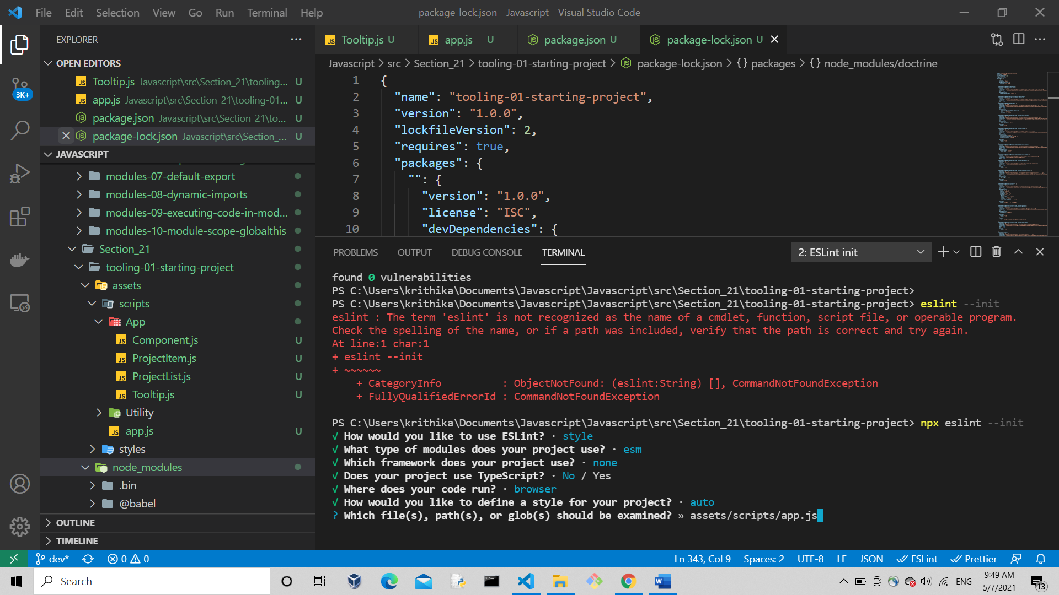

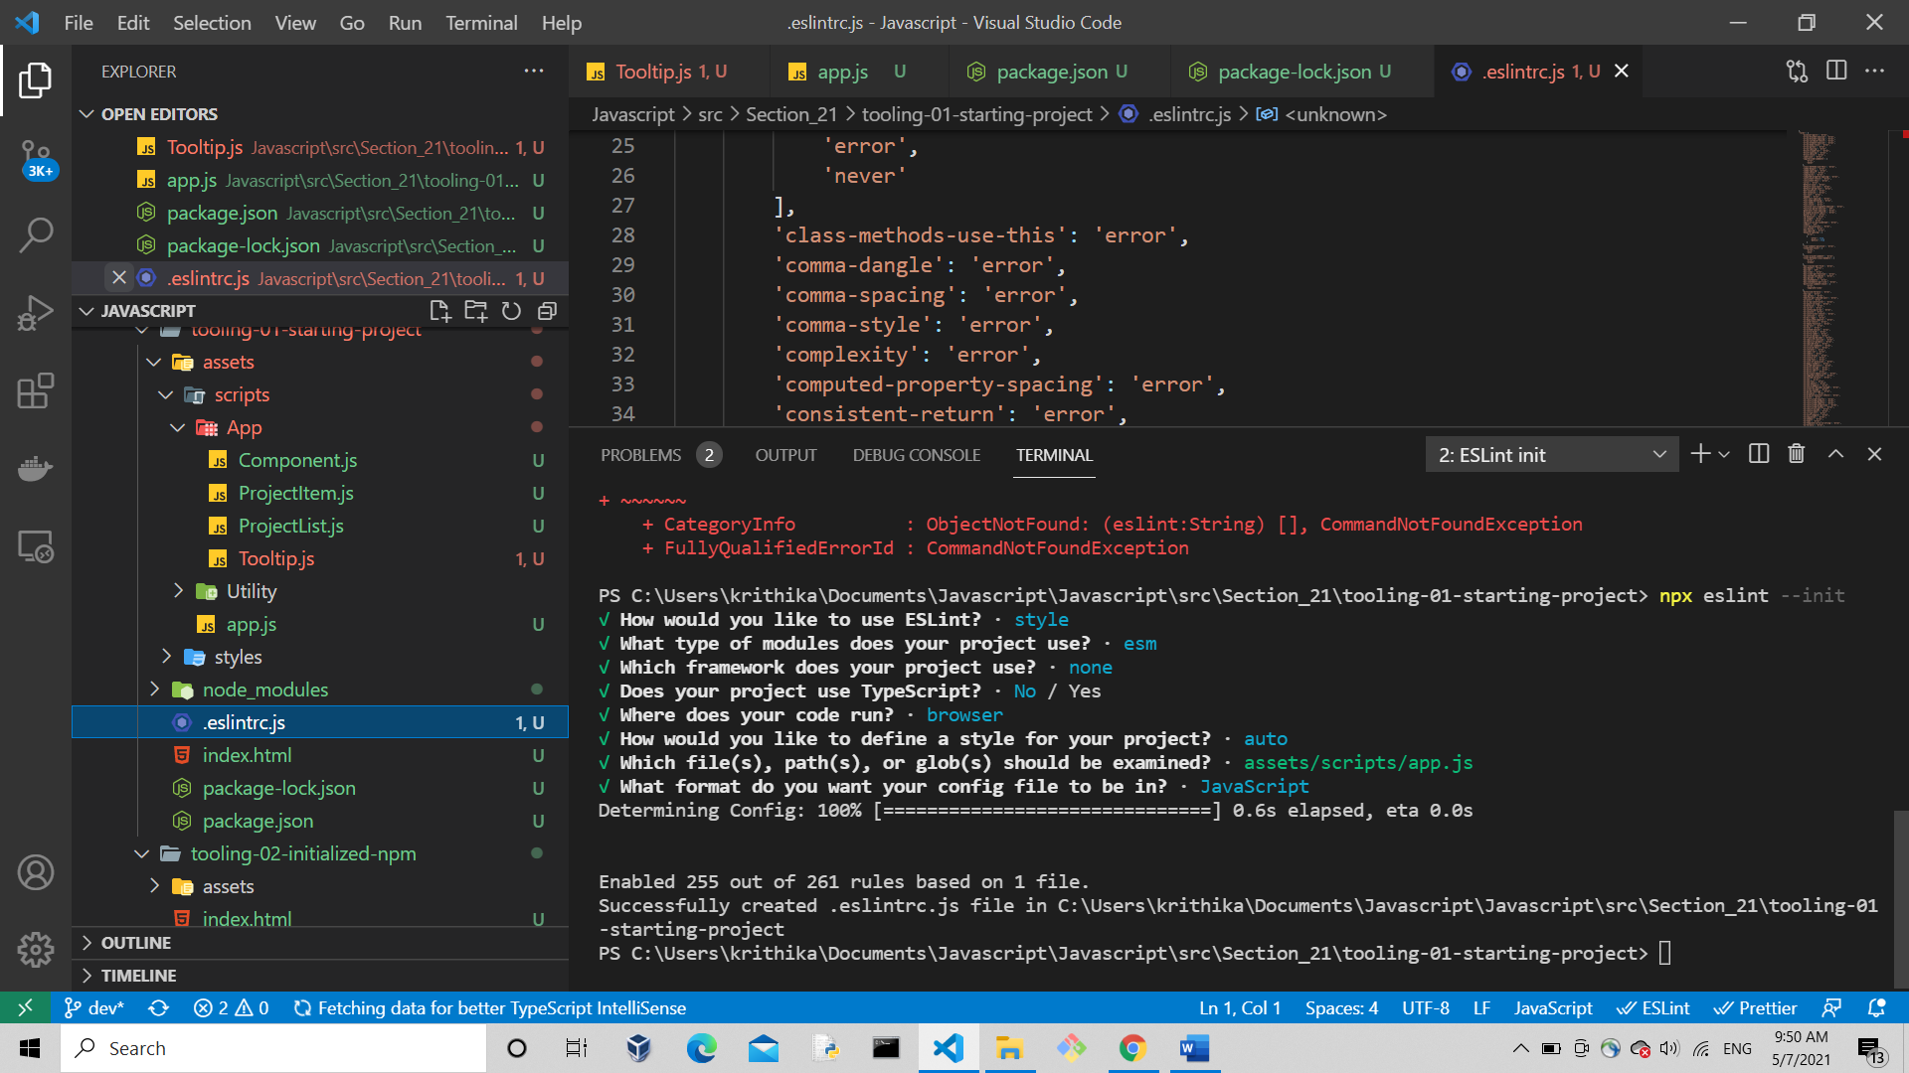

Chosed js so got .eslintric.js file, but chose json file and check the documentation in online to get details about how to use it <https://eslint.org/docs/user-guide/getting-started>

<https://www.npmjs.com/package/eslint>

installing webpack

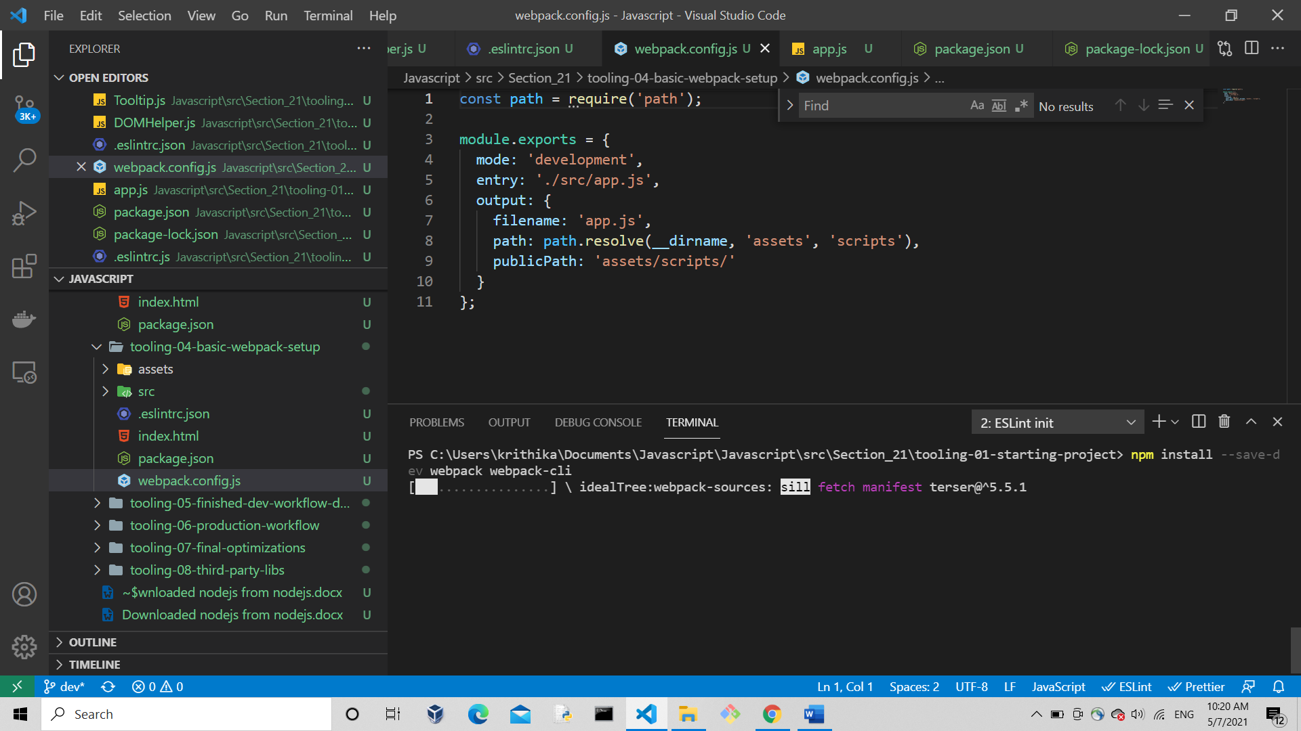

After installing, check the package.json file devdependencies are installed

Then manually create webpack.config.js file => in that file we have to give configuration for webpack

